**Home Work 3**

**CMPS356**

**Taofik Al Nass**

**201104285**

**Hifz Tracker**

**In this Document:**

**- Login-**

[**- USE CASE 1: Add Task-**](#_USE CASE 1: Add Task)

[**- USE CASE 2: Pending Tasks-**](#_USE CASE 2: Pending Tasks)

[**- USE CASE 3: Complete Tasks-**](#_USE CASE 3: Complete Task)

[**- USE CASE 3: Completed Tasks Page-**](#_USE CASE 4: Completed Tasks Page)

[**- USE CASE 3: Update-**](#_USE CASE 4: Update Task)

# Login

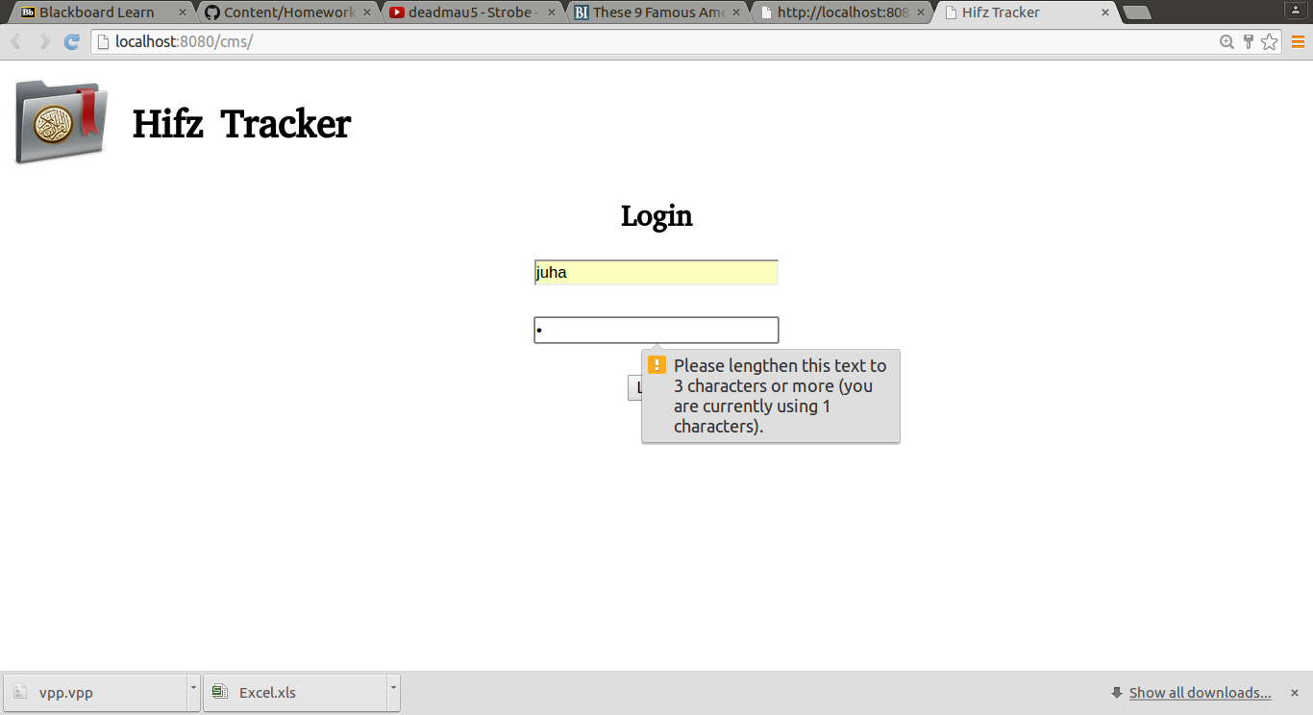

2 field login form, validation rules applied:

1- Username between 2 to 15 characters.

2- Password between 3 to 10 characters.

After login, the user will be taken to a page that shows their pending tasks.

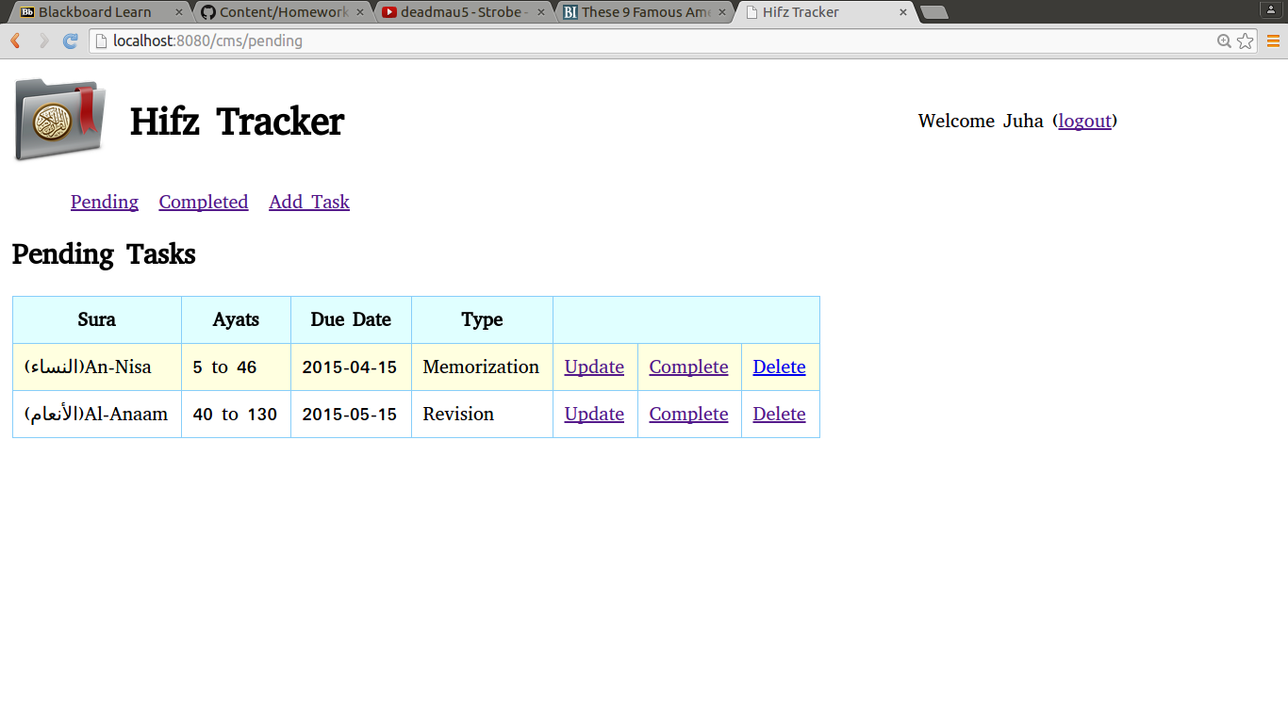

# USE CASE 1: Add Task

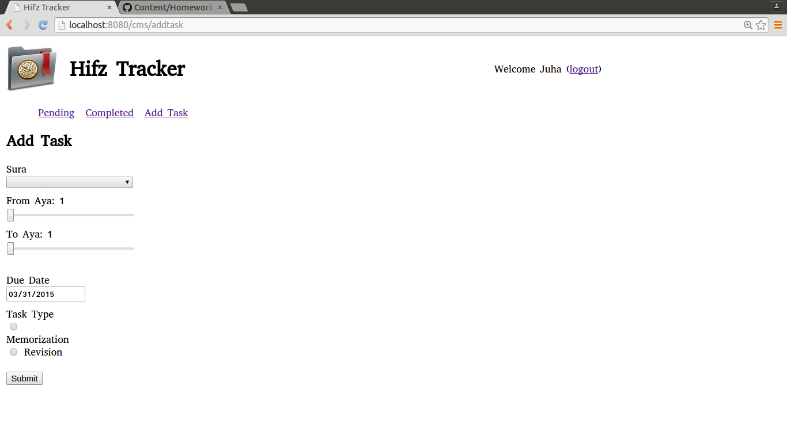

This page allows the user to add task information in order to later add it to their list of pending tasks, the user selects a sura, the max of both from aya and to aya will be updated to match the aya count of that specific sura.

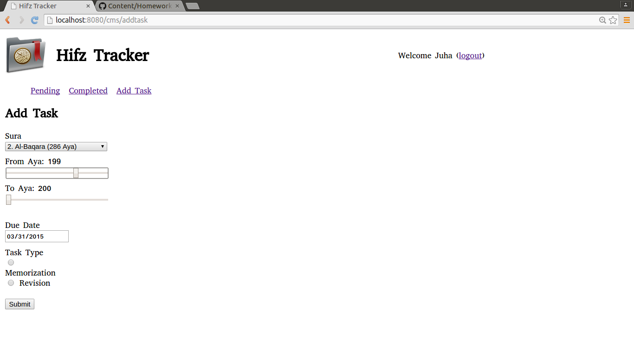

After the user clicks submit, he/she will be directed to pending tasks page where they will see a message declaring that the task has been added successfully, and they will see the task added to the list.

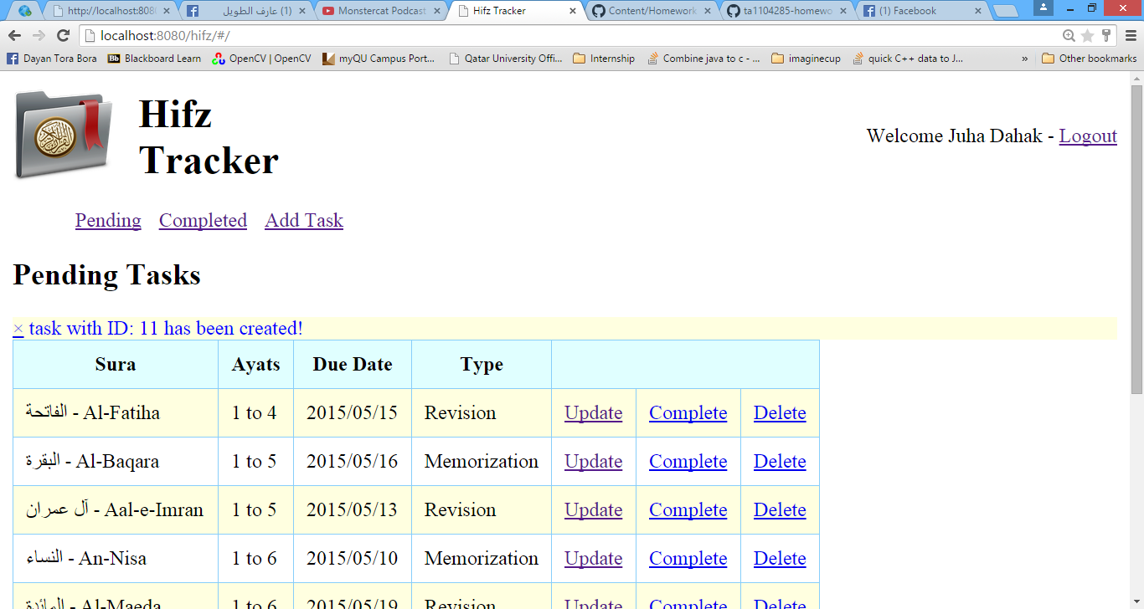

# USE CASE 2: Pending Tasks

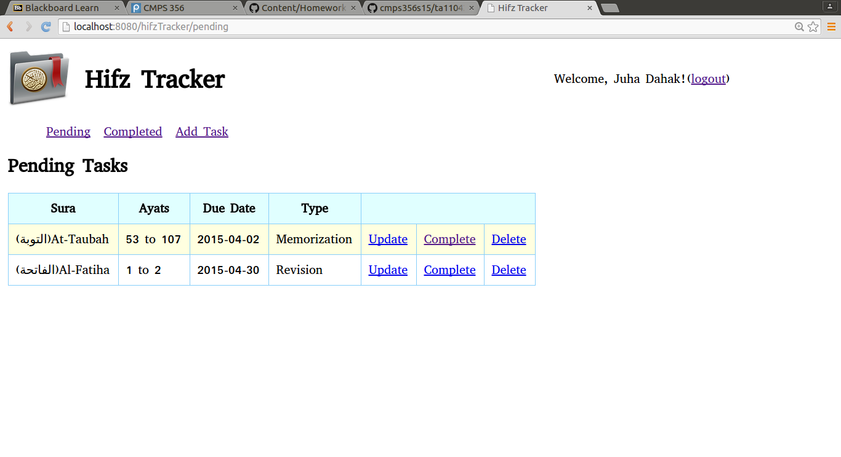

This page displays a list of Pending tasks and offers update, complete and delete options for each task.

# USE CASE 3: Complete Task

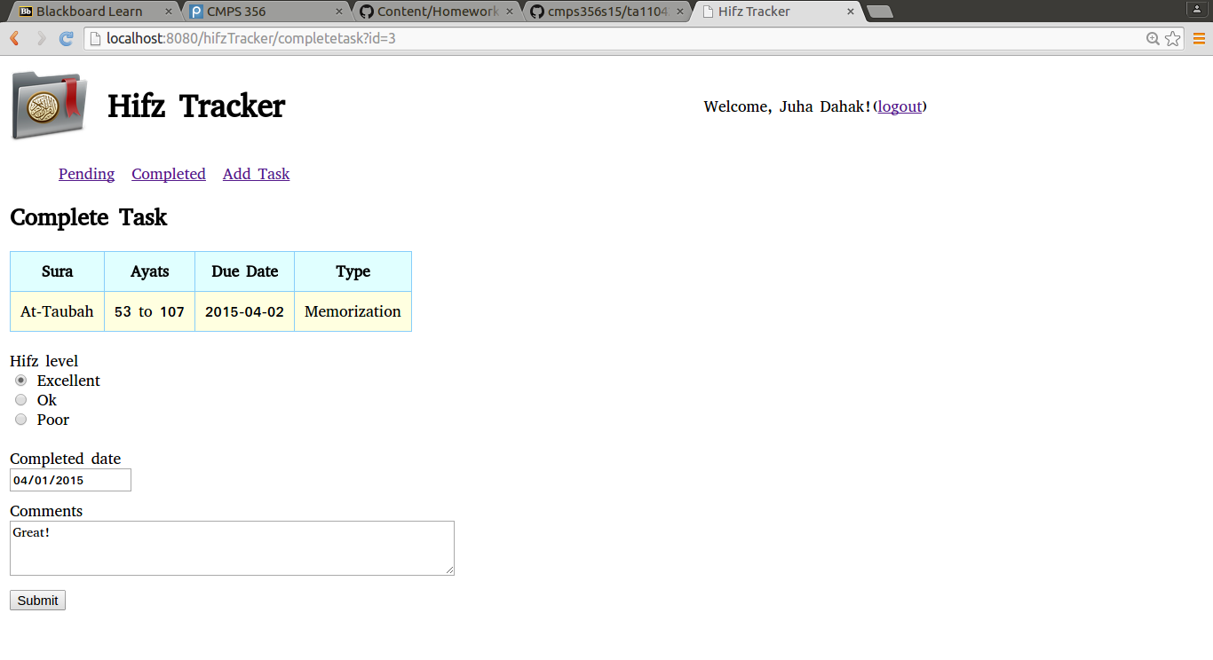

Selected task to be completed is displayed, user selects hifz level, complete date and adds comments.

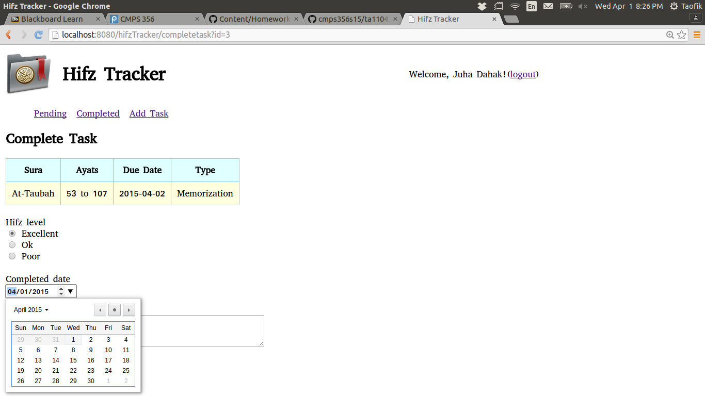

Submitting the form takes the user to Pending page, the completed task is removed from the pending task list and added to the completed task list.

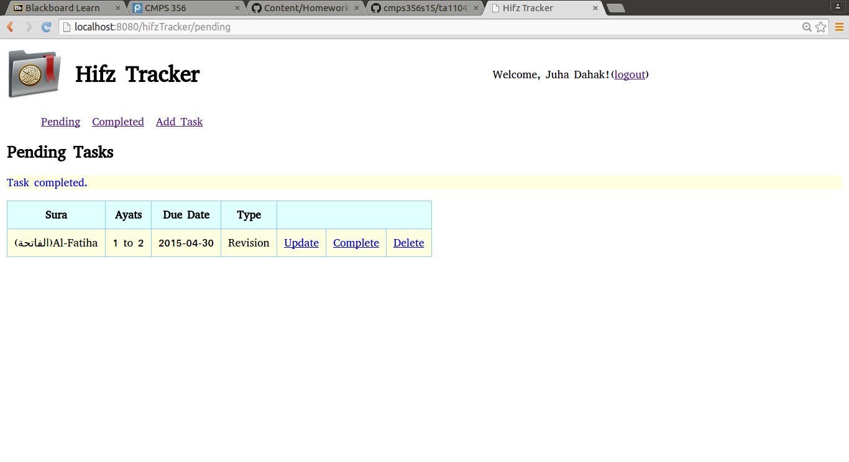

Task in Completed List :

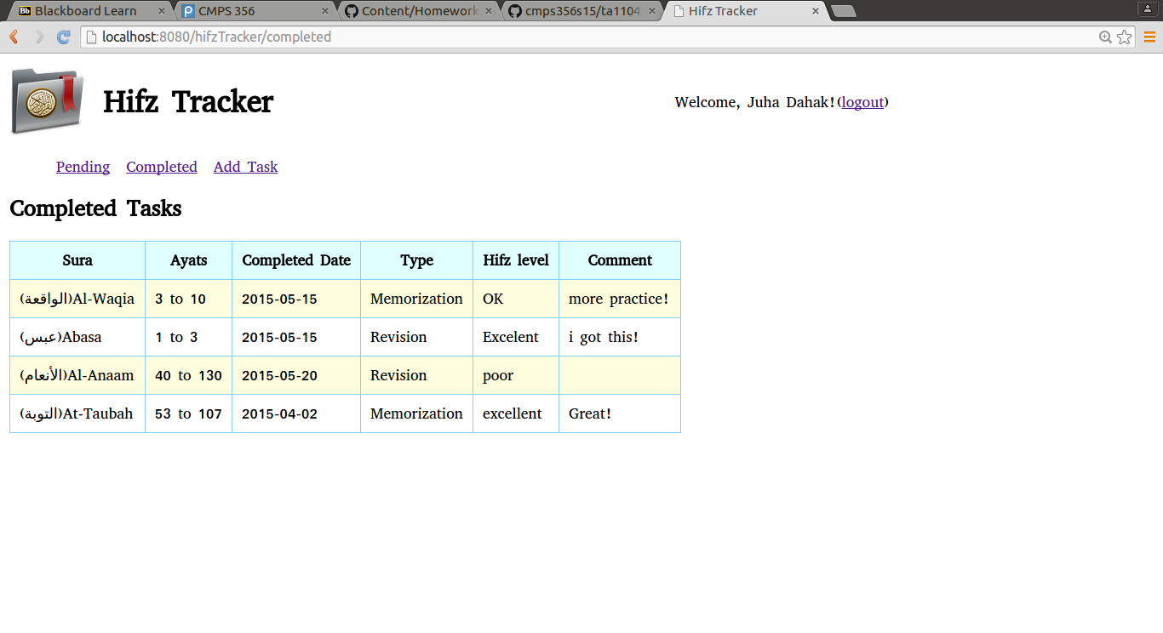

# USE CASE 4: Completed Tasks Page

This page shows all the previously completed tasks



# USE CASE 4: Update Task

In this use case, user can update a specific task, the current task information are loaded in the form and users can modify them and click submit to save changes.

